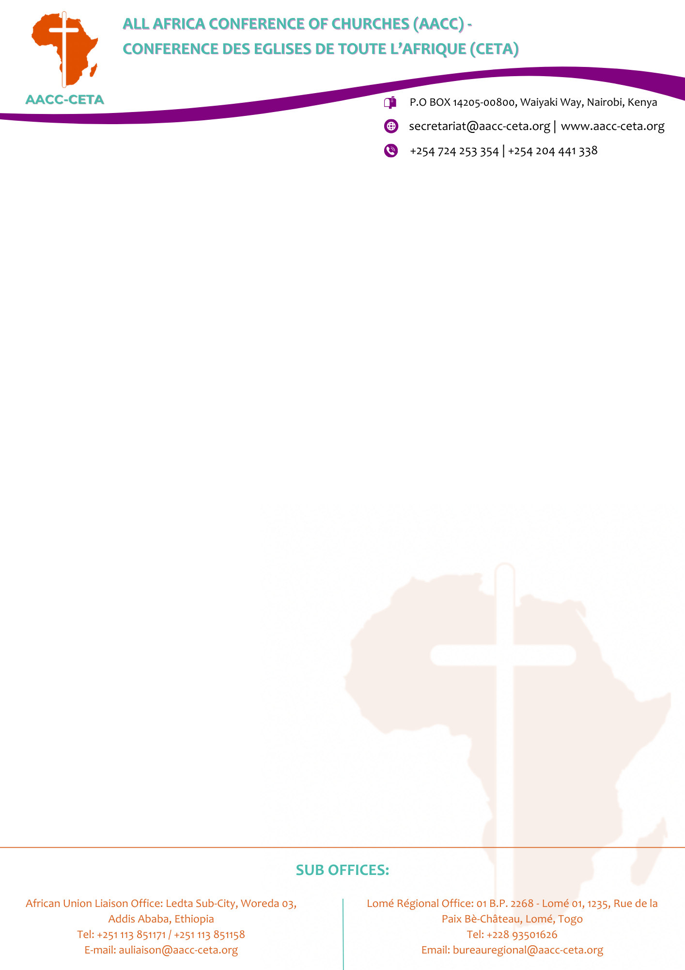

ALL AFRICA CONFERENCE OF CHURCHES (AACC) VACANCY ANNOUNCEMENT

POSITION: FRONT DESK AGENTS

REPORTING TO: ROOMS DIVISION MANAGER
BACKGROUND
The AACC is a fellowship of 217 Member Churches and Christian Councils in 43 African countries. The organization has its Secretariat in Nairobi, Kenya, a Regional Office in Lome, Togo and a Liaison Office to the African Union in Addis Ababa, Ethiopia.
The organization has a 100- room hotel with state of the art conference rooms, and gym. Management is looking for a self-motivated Front Desk Agents to support in the efficient running of the hotel.

JOB SUMMARY
We are seeking a professional, guest-focused and well-organized Front Desk Agents to join our pre-opening hotel team. The successful candidate will be responsible for delivering excellent guest service while efficiently handling check-in, check-out, guest enquiries, billing and Front Office operations.

KEY RESPONSIBILITIES
- Welcome and register guests in a warm, professional and efficient manner.
- Handle check-in and check-out procedures accurately in accordance with hotel standards.
- With the guidance of the RDM, manage room reservations, modifications, cancellations, no-shows and amendments.
- Process room allocations and ensure accurate guest information in the PMS.
- Monitor arrivals, departures, room status and special guest requests.
- Prepare and verify guest registration details, billing and payment information.
- Handle telephone calls, emails and guest enquiries professionally.
- Provide information on hotel facilities, services, local attractions and transportation.
- With the guidance of RDM, follow closely with Housekeeping to ensure accurate room status and timely room readiness.
- With the guidance of RDM liaise with Reservations, Restaurant, Sales and other departments to meet guest requirements.
- Handle guest complaints professionally and ensure effective service recovery and communication done to the RDM.
- Identify and implement opportunities for upselling rooms and hotel services.
- Maintain accurate records and ensure proper shift handover.
- Process payments and maintain accurate guest accounts in accordance with hotel procedures.

QUALIFICATIONS & EXPERIENCE
- Diploma or Degree in Hotel Management, Hospitality, Tourism or a related field.
- 2–3 years' experience in Front Office or Reservations, preferably in a hotel environment.
- Practical knowledge and experience using PMS is required/preferred.
- Good understanding of hotel Front Office and reservation procedures.
- Experience with hotel payment, billing and reservation systems is an advantage.
- Previous experience in a pre-opening hotel is an added advantage.
WORK STATION: AACC Desmond Tutu Conference Centre / Hotel, Nairobi - Kenya.
START DATE: 1ST OCTOBER, 2026.
DURATION OF EMPLOYMENT: One (1) year renewable based on satisfactory performance
APPLICATION:
- Applications should be accompanied by:
  - A Cover Letter.
  - Detailed Curriculum Vitae including Names and Addresses of 3 (three) referees.
  - Certified copies of all qualifications.
  - Filled Job Application Form.
- Interested candidates who meet the above criteria should send their applications to:
THE GENERAL SECRETARY
ALL AFRICA CONFERENCE OF CHURCHES
P.O BOX 14205 – 00800 WESTLANDS, NAIROBI KENYA
Or email to: hr-applications@aacc-ceta.org
SUBMISSION:
The deadline for submission is on 21st September, 2026. Only short-listed applicants meeting the above requirements will be contacted.

